AI STUDYBUDDY
AI-Powered Learning Platform
A Project Report

Project Title : AI Study Buddy
Team Leader : Lakshaya.S

Team Members : Harifa.R , Priyadharshini .V.B , Rogith .E
Course : B .Sc
Department : Computer Science
College : Vivekananda Vision Arts and Science College
Academic Year : 2026-2027
GitHub link : https://github.com/lakshaya200/AI-StudyBuddy.git
Demo link : https://drive.google.com/file/d/1hftMtTgfNw3inGZ5FoIXIZAcea9K-idV/view?usp=drivesdk

1. Introduction
AI StudyBuddy is an AI-powered learning platform designed to help students study and revise more effectively. It allows students to register, log in, add or upload study materials, and use AI-based learning features.
The system is developed using React.js, Node.js, Express.js, MongoDB, and Google Gemini AI. It provides AI-generated summaries, flashcards, quizzes, and personalized study plans.
The application uses JWT authentication and role-based access control to provide separate access for students and administrators. The main aim of AI StudyBuddy is to provide a simple and organized platform for learning and self-assessment

2. Problem Statement
Students often spend considerable time preparing summaries, revision notes, and questions manually. Managing study materials and learning activities through different applications can also be inconvenient.
Therefore, there is a need for a centralized learning platform that can help students organize their study materials and generate useful learning content using Artificial Intelligence.
AI StudyBuddy addresses this problem by providing a single platform where students can manage their study materials and generate AI-based learning content for effective study and revision.

3. Objectives
- To provide secure student registration and login.
- To allow students to add and upload study materials.
- To generate AI-based summaries for easy understanding.
- To generate AI flashcards for quick revision.
- To generate AI quizzes for self-assessment.
- To generate personalized study plans.
- To implement JWT authentication and role-based access control.
- To store user and study material data using MongoDB.

4. Scope
- Provides a platform for students to manage their study materials.
- Allows students to add and upload learning materials.
- Generates AI-based summaries, flashcards, ad quizzes.
- Provides personalized study plans using AI.
- Provides secure login using JWT authentication. n
- Supports separate Student and Admin roles.
- Allows administrators to manage user roles.
- Stores user and study material data using MongoDB.

5. Technologies Used
Technology | Purpose
React.js | Used to develop the frontend user interface.
Node.js | Used to run the backend server.
Express.js | Used to create REST APIs and handle backend requests.
MongoDB | Used to store user and study-related data.
Mongoose | Used to connect the backend with MongoDB and manage data models.
Google Gemini AI | Used to generate summaries, flashcards, quizzes, and study plans.
JWT | Used for user authentication and role-based access control.
Bcryptjs | Used to hash user passwords securely.
Multer | Used to handle study material file uploads.
HTML & CSS | Used to structure and style the frontend.

6. System Requirements

Hardware Requirements
- Processor: Intel Core i3 or above
- RAM: 4 GB or above
- Storage: 10 GB free space
- System: Windows 10/11 or equivalent

Software Requirements
- Operating System: Windows 10/11
- Frontend: React.js
- Backend: Node.js and Express.js
- Database: MongoDB
- IDE: Visual Studio Code
- Browser: Google Chrome
- AI Service: Google Gemini API
- API Testing: Thunder Client

7. System Architecture
AI StudyBuddy follows a client-server architecture. The React.js frontend communicates with the Node.js and Express.js backend through REST APIs. The backend handles authentication, study materials, AI requests, and database operations. MongoDB stores user and study material data, while Google Gemini AI is used to generate learning content.
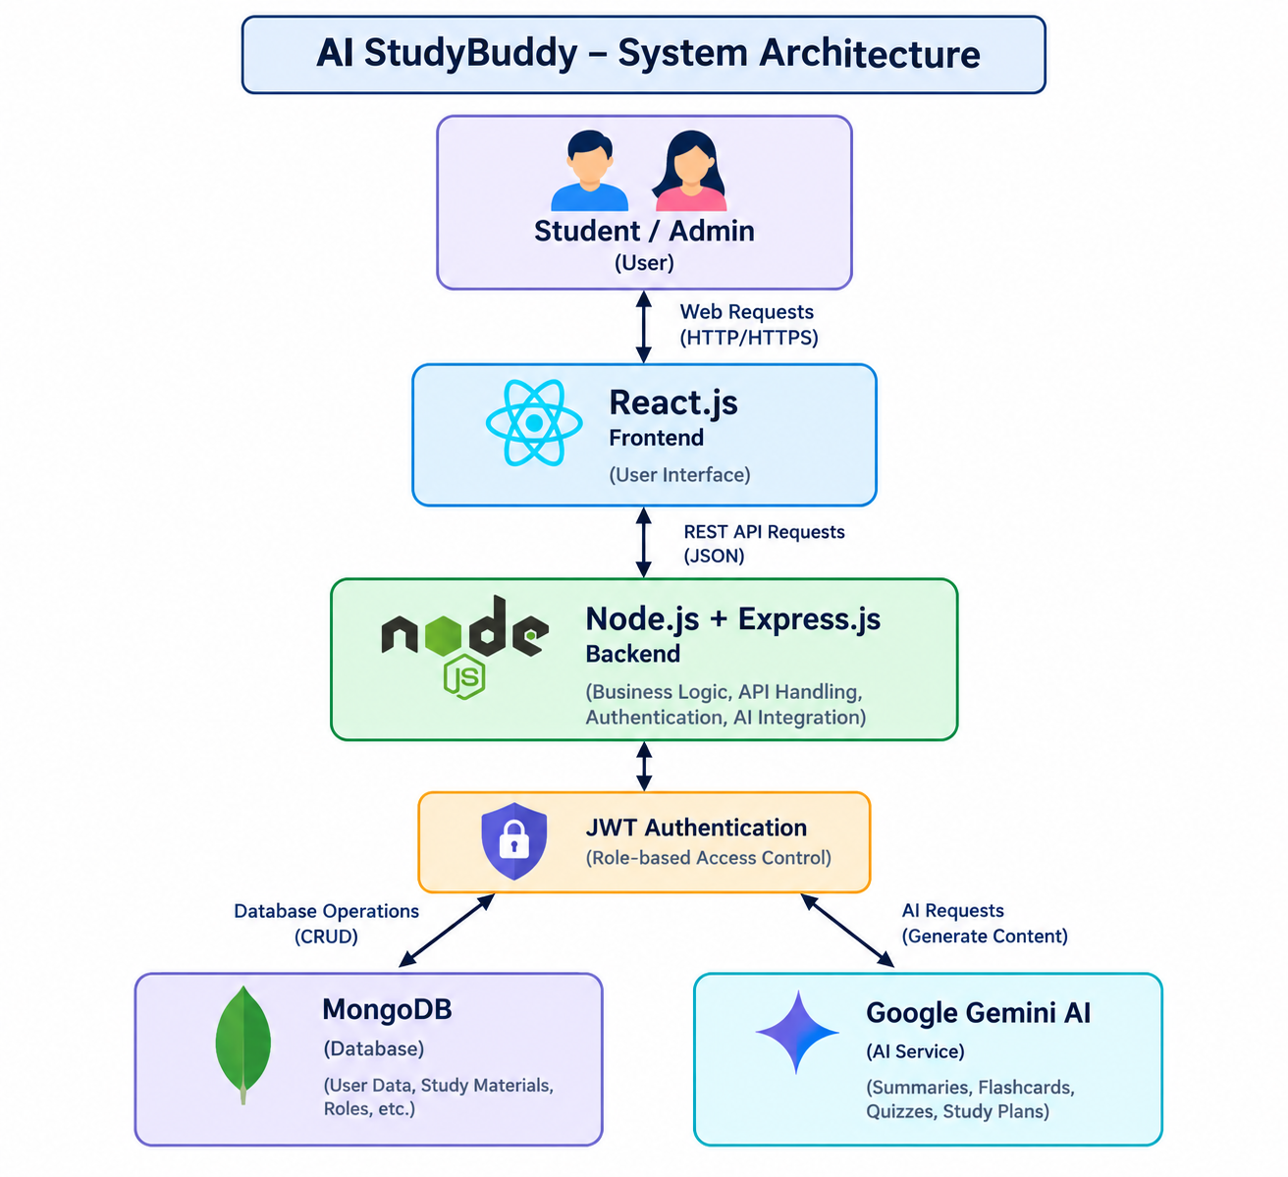

8. Modules

8.1 User Authentication Module
The Authentication Module provides secure registration and login functionality for users. Passwords are securely hashed using bcryptjs, and JWT tokens are used for authentication. The system identifies users as either students or administrators.

8.2 Study Material Module
The Study Material Module allows students to add study materials and upload files. The materials are stored in MongoDB and can be accessed by the respective student.

8.3 AI Learning Module
The AI Learning Module integrates Google Gemini AI to generate useful learning content.
- AI Summary
- AI Flashcards
- AI Quiz
- Personalized Study Plan

8.4 Admin Module
The Admin Module provides administrators with access to user management. Admins can view registered users and change their roles between Student and Admin.

8.5 File Upload Module
The File Upload Module allows students to upload study material files through the application. The uploaded files are handled using Multer.

9. Database Design

9.1 Database Used
MongoDB is used as the database for AI StudyBuddy. It stores user information, study materials, AI-generated learning content, and role information.

9.2 Main Collections
Collection | Purpose
Users | Stores user name, email, hashed password, and role.
Materials | Stores study material title, content, user details, and file information.
Summaries | Stores AI-generated summaries related to study materials.
Flashcards | Stores AI-generated questions and answers for revision.
Quizzes | Stores AI-generated quiz content.
StudyPlans | Stores generated personalized study plans.

9.3 Database Relationship
- A User can have multiple study materials.
- Each Study Material belongs to a specific user.
- AI-generated summaries, flashcards, quizzes, and study plans are associated with study materials and users.
- User roles are stored to support Student and Admin access.

10. Implementation

10.1 Frontend Implementation
The frontend of AI StudyBuddy is developed using React.js. It provides separate interfaces for students and administrators. The frontend communicates with the backend through REST API requests.

10.2 Backend Implementation
The backend is developed using Node.js and Express.js. It handles authentication, study material management, file uploads, AI requests, and admin operations through REST APIs.

10.3 Authentication and Authorization
User passwords are hashed using bcryptjs. After successful login, a JWT token is generated. The token is used to authenticate protected requests. Role-based access control provides separate permissions for students and administrators.

10.4 AI Integration
Google Gemini AI is integrated with the backend to generate:
- Summaries
- Flashcards
- Quizzes
- Personalized study plans
The generated AI content is returned through backend APIs and displayed in the React frontend.

10.5 File Upload
The application uses Multer to handle study material file uploads. Uploaded files are processed by the backend and associated with the user's study materials.

10.6 API Implementation
- User Registration and Login
- Study Material Management
- AI Summary Generation
- AI Flashcard Generation
- AI Quiz Generation
- AI Study Plan Generation
- File Upload
- Admin User Management

11. Testing
Test Case | Functionality | Expected Result | Status
TC01 | Student Registration | New student account should be created successfully. | Pass
TC02 | Student Login | Student should access the Student Dashboard. | Pass
TC03 | Admin Login | Admin should access the Admin Dashboard. | Pass
TC04 | Add Study Material | Study material should be saved and displayed. | Pass
TC05 | File Upload | Study material file should be uploaded successfully. | Pass
TC06 | Admin User Management | Admin should be able to view and change user roles. | Pass
TC07 | JWT Authentication | Protected APIs should allow only authenticated users. | Pass
TC08 | Role-Based Access | Students and admins should receive their respective access. | Pass
TC09 | AI Summary | AI summary should be generated from study material. | Pass
TC10 | AI Flashcards | AI flashcards should be generated from study material. | Pass
TC11 | AI Quiz | AI quiz should be generated from study material. | Pass
TC12 | AI Study Plan | Personalized study plan should be generated. | Pass

12. Screenshots / Output
The following screenshots show the main user interface, study material management, administrator functions, and database role information of AI StudyBuddy.

- AI StudyBuddy Login Page:

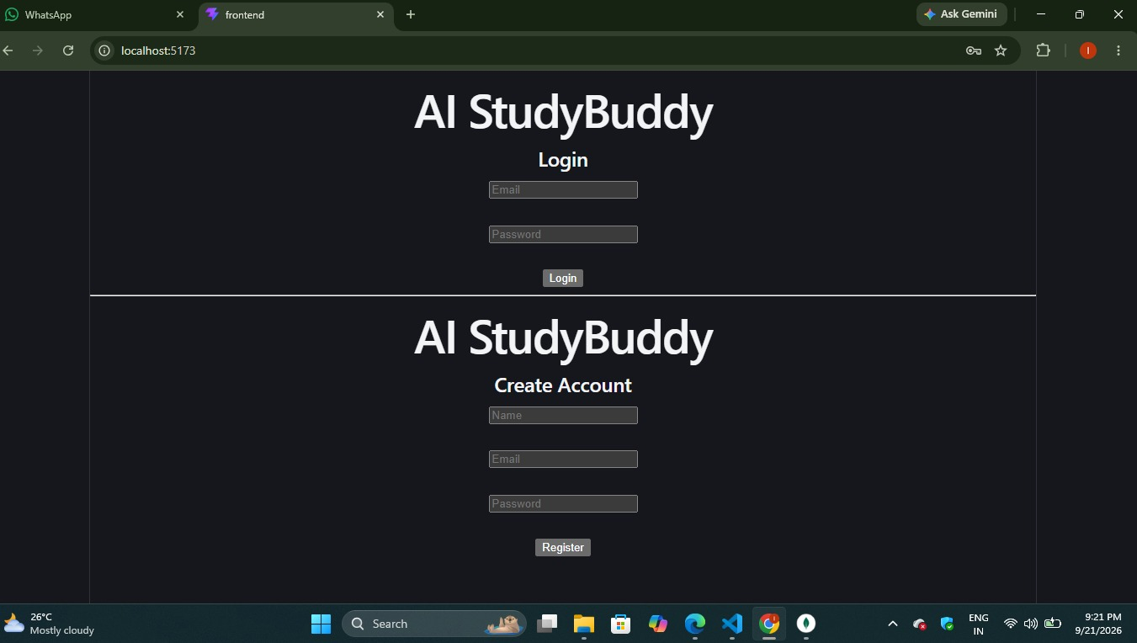

- Student Dashboard:
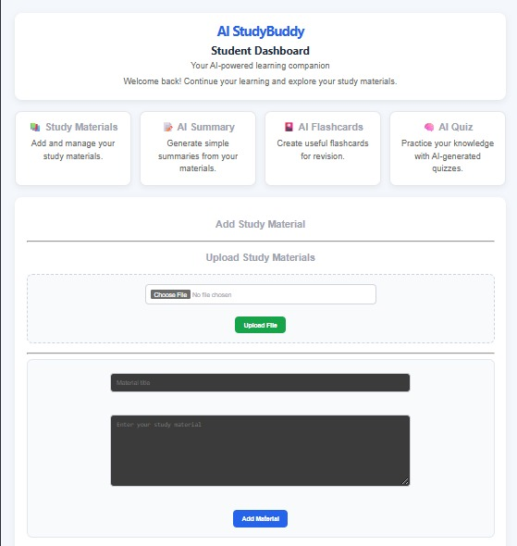

3.Study Materials:
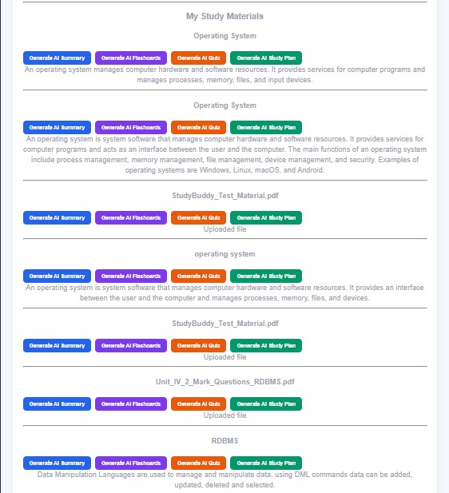

4 .Admin Dashboard:
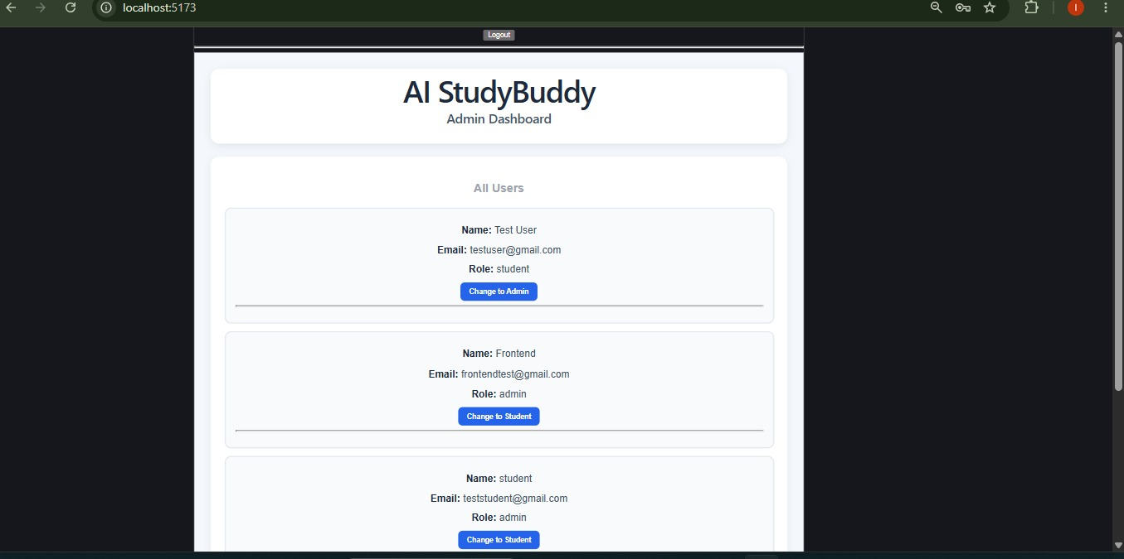
5.User Roles Stored in MongoDB:
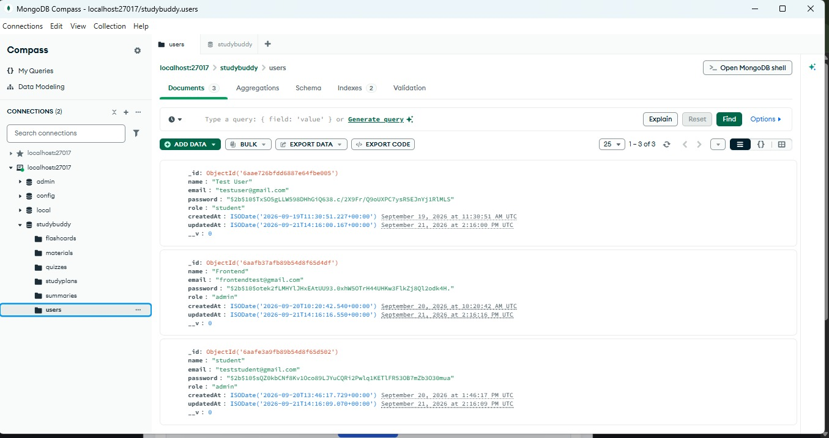

6. AI FlashCards:
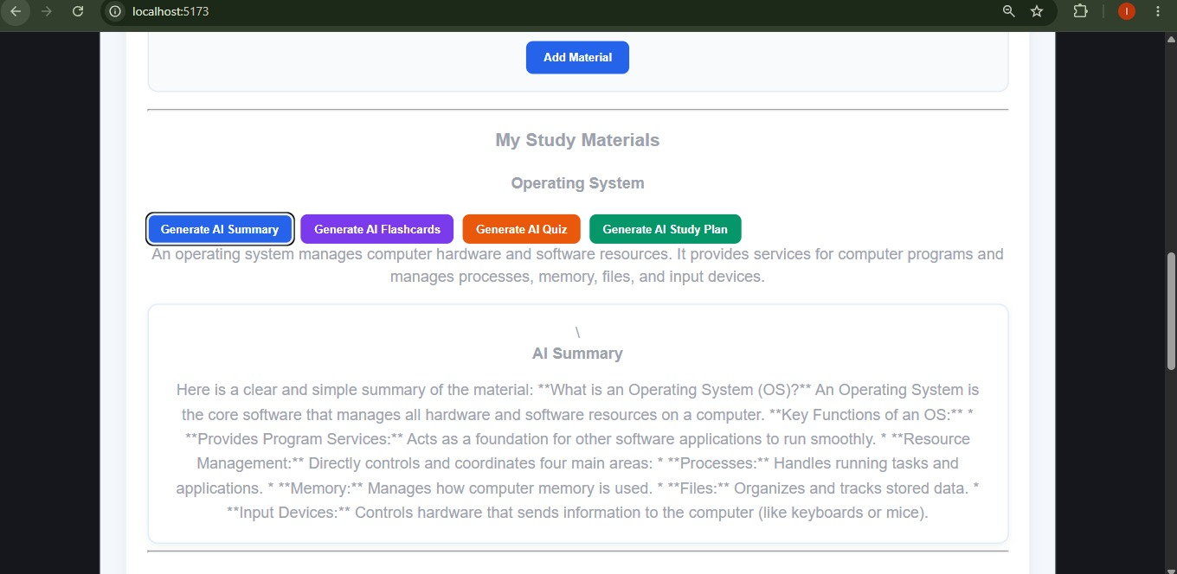

7.AI Summary:
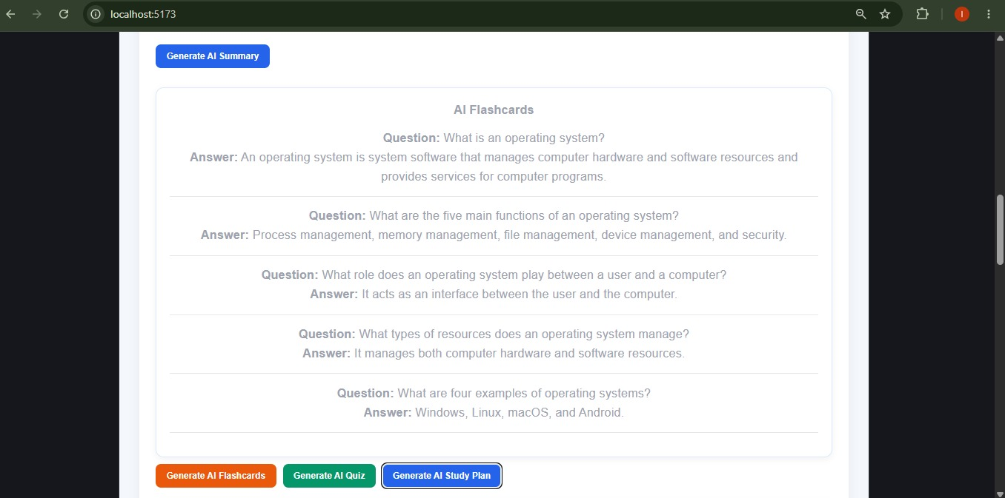

8. AI Study Plan:
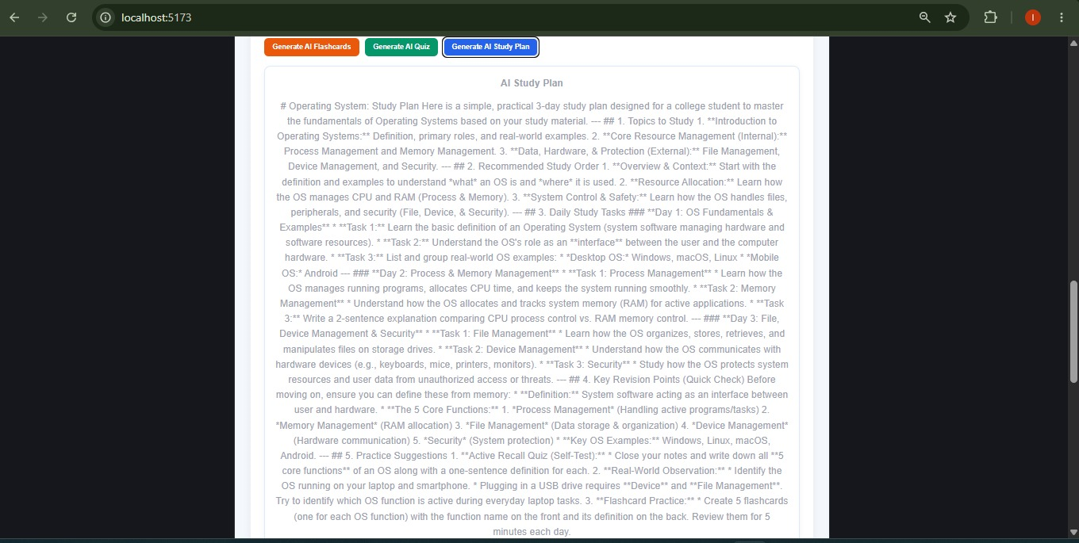
9. AI Quiz:
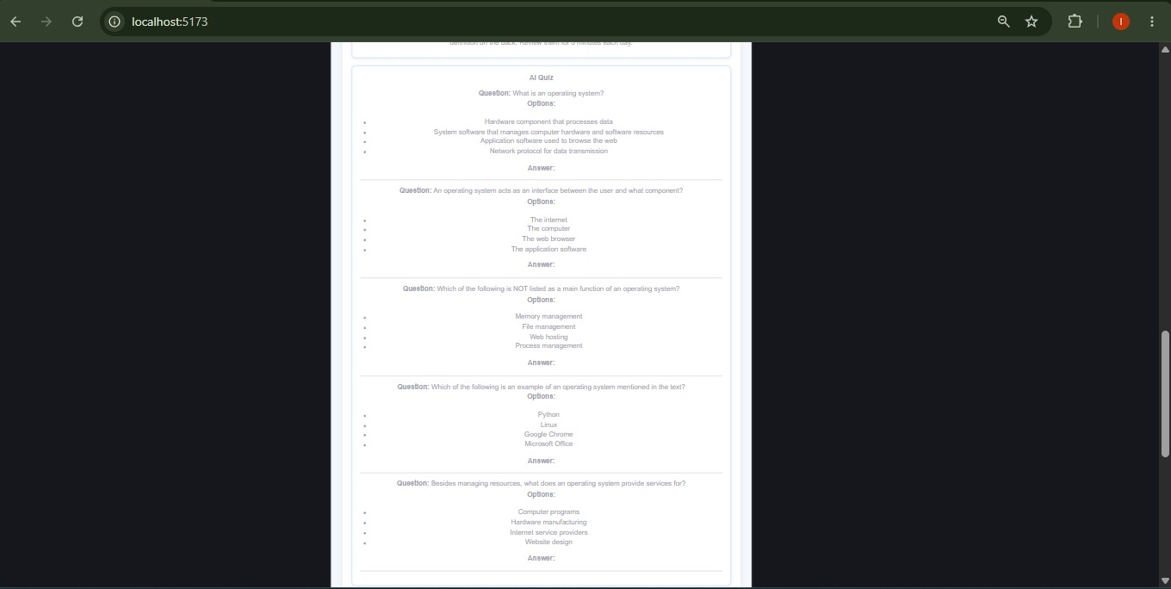

13. Advantages
- Provides a centralized platform for managing study materials.
- Generates AI-based summaries for quick understanding.
- Provides flashcards for effective revision.
- Generates quizzes for self-assessment.
- Provides personalized study plans.
- Provides secure login using JWT authentication.
- Supports separate Student and Admin roles.
- Stores user and study material data using MongoDB.

14. Limitations
- AI-generated content depends on the availability of the Gemini AI service.
- The quality of AI-generated content depends on the study material provided.
- The application requires an internet connection for AI features.
- The current system supports basic study material file uploads.
- The application is mainly designed for student learning and revision.

15. Future Enhancements
- Add advanced AI-based personalized learning recommendations.
- Support more study material file formats.
- Add progress tracking and learning analytics.
- Add notifications and study reminders.
- Improve the user interface for better accessibility.
- Add more interactive learning features.

16. Conclusion
AI StudyBuddy is an AI-powered learning platform that helps students manage study materials and improve learning through AI-generated summaries, flashcards, quizzes, and study plans.
The project uses React.js, Node.js, Express.js, MongoDB, JWT authentication, and Google Gemini AI to provide a secure and organized learning experience.

17. References
- React.js Documentation
- Node.js Documentation
- Express.js Documentation
- MongoDB Documentation
- Google Gemini API Documentation
- MDN Web Docs

